**Course ___Methods_Test 4_ Year __12_______**

Student name: ________________ Teacher name: ________________

Date: **Weds 26 August**

**Task type: Response**

**Time allowed for this task: _____45______ mins**

**Number of questions: _____6______**

**Materials required:** Calculator with CAS capability (to be provided by the student)

Standard items: Pens (blue/black preferred), pencils (including coloured), sharpener, correction fluid/tape, eraser, ruler, highlighters

Special items: Drawing instruments, templates, notes on one unfolded sheet of   
A4 paper, and up to three calculators approved for use in the WACE examinations

**Marks available: __46____ marks**

**Task weighting: __10__%**

**Formula sheet provided: Yes**

**Note: All part questions worth more than 2 marks require working to obtain full marks.**

Q1 (1, 1, 1 & 3 = 6 marks)

Consider a continuous random variable X that is uniformly distributed as follows.

Determine the following:

1. 

|  |
| --- |
| **Solution** |
|  |
| **Specific behaviours** |
| 🗸 determines area |

1. 

|  |
| --- |
| **Solution** |
| Same result as (a) |
| **Specific behaviours** |
| 🗸 same result as (a) |

1. 

|  |
| --- |
| **Solution** |
| 1 |
| **Specific behaviours** |
| 🗸 states prob |

1. 

|  |
| --- |
| **Solution** |
|  |
| **Specific behaviours** |
| 🗸 uses conditional formula/idea  🗸 correct denominator  🗸 correct prob |

Q2 (3 marks)

Consider a continuous random variable X shown below.

Solve for the constant exactly. (Show all working)



 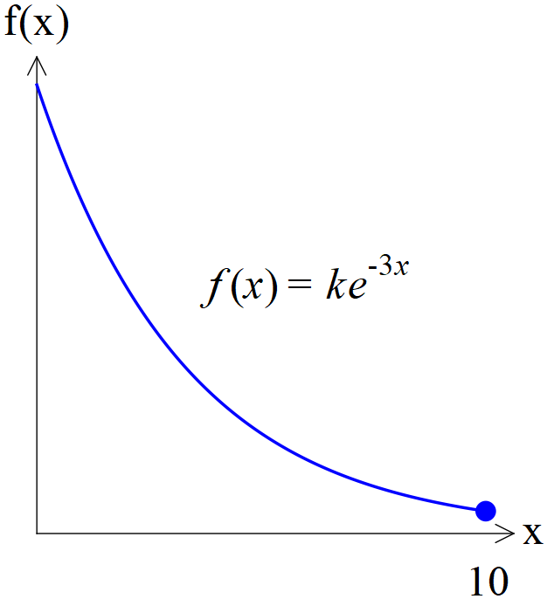

|  |
| --- |
| **Solution** |
|  |
| **Specific behaviours** |
| 🗸 uses integral with correct limits  🗸 solves backwards from a total area of one  🗸 states exact value of k |

Q3 (1, 4, 1 & 2 = 8 marks)

Consider a continuous random variable X shown below. (Not drawn to scale)

1. Determine the value of the constant .

|  |
| --- |
| **Solution** |
|  |
| **Specific behaviours** |
| 🗸 states value |

1. Determine 

|  |
| --- |
| **Solution** |
|  |
| **Specific behaviours** |
| 🗸 determines equation of one slope or uses similar triangles  🗸 determines equation of second slope or uses similar triangles  🗸 uses integration or trapeziums to find areas  🗸 states final value |

1. Determine 

|  |
| --- |
| **Solution** |
| 3 by inspection and the symmetry around x=3 |
| **Specific behaviours** |
| 🗸 states value |

1. Determine Standard deviation of 

|  |
| --- |
| **Solution** |
|  |
| **Specific behaviours** |
| 🗸 states correct integral for 0 to 3  🗸 states correct integral for 3 to 6 and approx. answer for stdev  (full marks for answer only) |

Q4 (2, 2 ,2 & 1 = 7 marks)

A continuous random variable,  has a pdf 

Determine:

1. 

|  |
| --- |
| **Solution** |
|  |
| **Specific behaviours** |
| 🗸 uses correct integral  🗸 states mean |

1. 

|  |
| --- |
| **Solution** |
|  |
| **Specific behaviours** |
| 🗸 uses correct integral  🗸 states Variance |

1. Standard deviation

|  |
| --- |
| **Solution** |
|  |
| **Specific behaviours** |
| 🗸 uses square root  🗸 states standard dev |

1. 

|  |
| --- |
| **Solution** |
|  |
| **Specific behaviours** |
| 🗸 multiplies by 9 |

Q5 (2, 2, 2 & 3 =9 marks)

The results for a class test,  can be modelled by a Normal Distribution given by .

Determine:

1. The 78th percentile.

|  |
| --- |
| **Solution** |
|  |
| **Specific behaviours** |
| 🗸 uses inverse prob  🗸 states percentile |

1. 

|  |
| --- |
| **Solution** |
|  |
| **Specific behaviours** |
| 🗸 uses correct parameters  🗸 states prob |

1. The cut-off for an A grade given that this grade is only given to the top 20%.

|  |
| --- |
| **Solution** |
|  |
| **Specific behaviours** |
| 🗸 uses right tail  🗸 states cut off |

1. A second test is a Normal Distribution with a mean of 55. Given that the 58th percentile is 62, determine the standard deviation.

|  |
| --- |
| **Solution** |
|  |
| **Specific behaviours** |
| 🗸 solves for z score  🗸 uses rule that links x and z scores  🗸 solves for standard dev |

Q6 (3, 3, 3, 2 & 2 =13 marks)

The time it takes to be served at a supermarket checkout,  seconds, can be modelled by a normal distribution as follows  seconds. The assistant at the check out is paid according to the following scheme.

1. Fill in the probability line of the above table rounded to three decimal places.

|  |
| --- |
| **Solution** |
| |  |  |  |  |  |  | | --- | --- | --- | --- | --- | --- | | Time served  In seconds |  |  |  |  |  | | Payment $P | $5 | $7 | $12 | $15 | $18 | | Probability  To 4 decimal places | 0.0114  Or  0.0117 | 0.0642 | 0.8655 | 0.0580 | 0.0006  Or  0.0009 | |
| **Specific behaviours** |
| 🗸 contains two correct probs  🗸 contains five correct probs  🗸 all probs rounded to 3 or 4 dp |

1. Determine the expected payment  showing full working.

|  |
| --- |
| **Solution** |
|  |
| **Specific behaviours** |
| 🗸 shows sum of products  🗸 uses 5 products  🗸 determines mean (accept different values of probs) (2 marks for answer only) |

1. Determine the variance of the payment  showing full working.

|  |
| --- |
| **Solution** |
|  |
| **Specific behaviours** |
| 🗸 uses mean from b in calc  🗸 uses correct sum of terms  🗸 determines variance (2 marks for answer only) |

1. If the payments were all increased by 30% and a bonus of $2 added to each category, determine the new mean and standard deviation.

|  |
| --- |
| **Solution** |
|  |
| **Specific behaviours** |
| 🗸 determines new mean  🗸 determines new standard deviation |

1. Explain a limitation of the Normal distribution model and show a calculation to support this.

|  |
| --- |
| **Solution** |
| Model allows negative times |
| **Specific behaviours** |
| 🗸 mentions negative times  🗸 states a positive prob that time is less than zero |